Clayton-le-Woods Church of England Primary School
“With God we Grow”

Head Teacher: Mrs S. Pennington Tel No: 01772 335 030 Website: http://www.clayton-le-woods.lancs.sch.uk
Facebook page: https://www.facebook.com/claytonlewoodsprimary Address: Back Lane, Clayton-le-Woods, Chorley, PR6 7EU

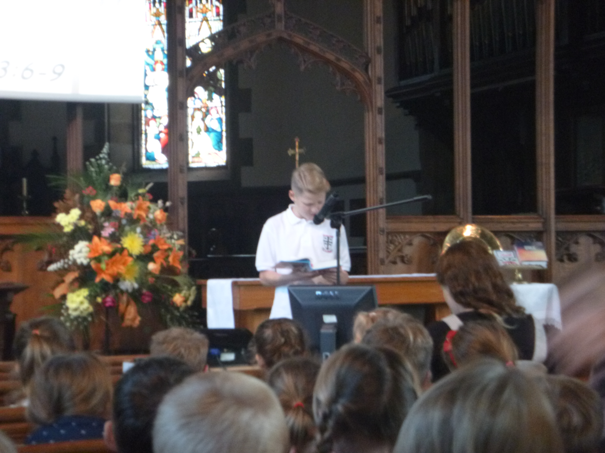
ATTENDANCE
Attendance figures for the whole school w/b 08/10/18 97.23%
Congratulations to Year 2
who had the highest attendance last week.
Monday Worship
As part of our celebration worship on Monday afternoons, I'd love to see some pictures of children and their achievements at home that we can share with the whole school. This could be any activity they've done where they have a great sense of achievement, from riding a bike for the first time to beating their grandad at chess.

Please send your pictures to p.howard@clayton-le-woods.lancs.sch.uk and they'll be added to a slideshow that will be played coming in to and leaving worship.
Many thanks, Mr Howard

HEADTEACHER’S COMMENTS

Unbelievably it will be half term next week. I hope that you enjoy the time together. After School Club will close at 5.30pm as usual on Friday. School re opens at 8.40am on Monday, October 29th. I have had an email from Cuerden Valley to say that car parking charges will start soon. They have said that they will let us know the exact date in plenty of time. We will send out a text as soon as the date is confirmed.

The reception classroom is being refurbished during the half term holiday. We have been waiting for a long time to be able to complete this project and are very excited. The work is planned to be completed in the holiday.

Have a great holiday!

Mrs S Pennington

Last week’s attendance by class

1st Year 2 99.64%
2nd Year 5 98.80%
3rd Year 3 98.33%
4th Year 4 97.41%
5th Year R 95.63%
6th Year 6 95.20%
7th Year 1 93.85%

Our target this year for attendance is 97.5%
Don’t forget your child will miss important lessons if they do not attend.

Holidays will ONLY be authorised for EXTREME circumstances as per the policy of the school taken from Lancashire County Council (LCC).

NASEL FLU VACCINATION for Yr’s Reception, 1, 2, 3, 4, 5.

On the 6th November nurses will be coming in to administer the nasel flu vaccination.
Please have a look at the website with information for parent to look at to understand why and how the nasel flu vaccination works.

Please visit www.sharegoodtimesnotflu.co.uk

SCHOOL PHOTOGRAPHS NEED TO BE RETURNED BY THE 30TH OCTOBER 2018.

PRE-SCHOOL

We have places available in Pre School, if you would like your 3 or 4 year old to start Pre School contact the school office and we can arrange a tour around Pre School.

We accept the 15 hours grant and 30 hours FREE childcare grant. Pre School children can also access our before and after school club.
WWW.childcarechoices.gov.uk
Please visit the above website to see if you are entitled to the 30 hours grant.

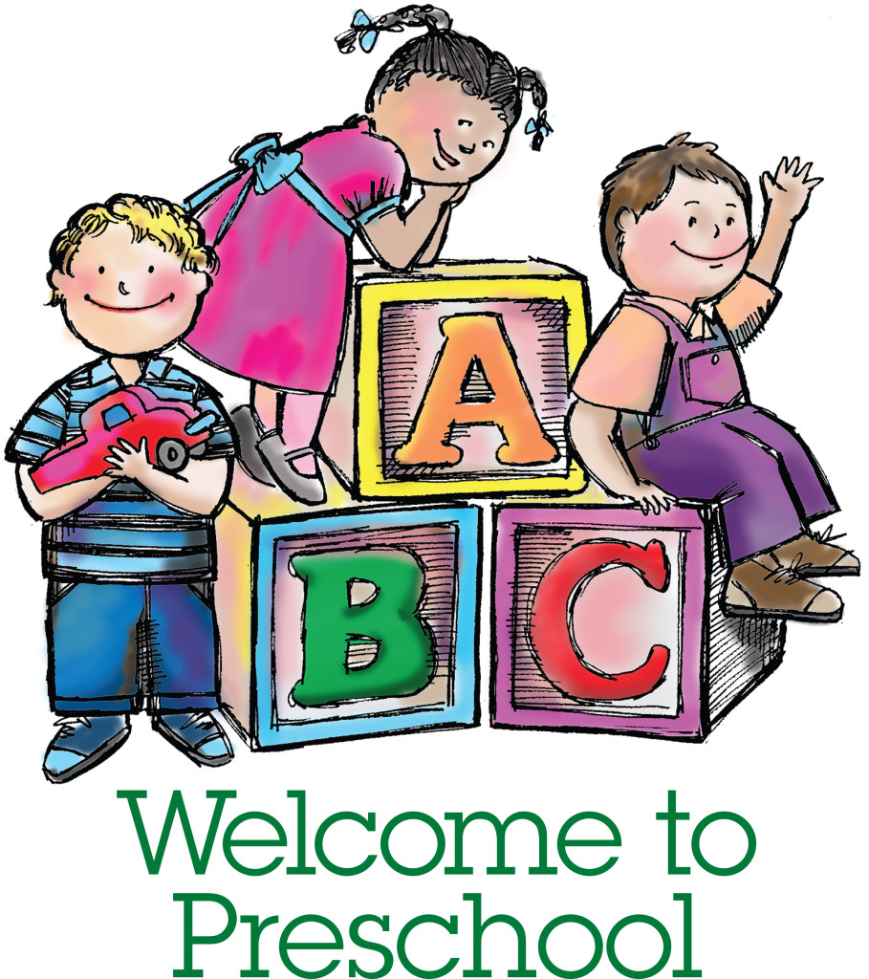

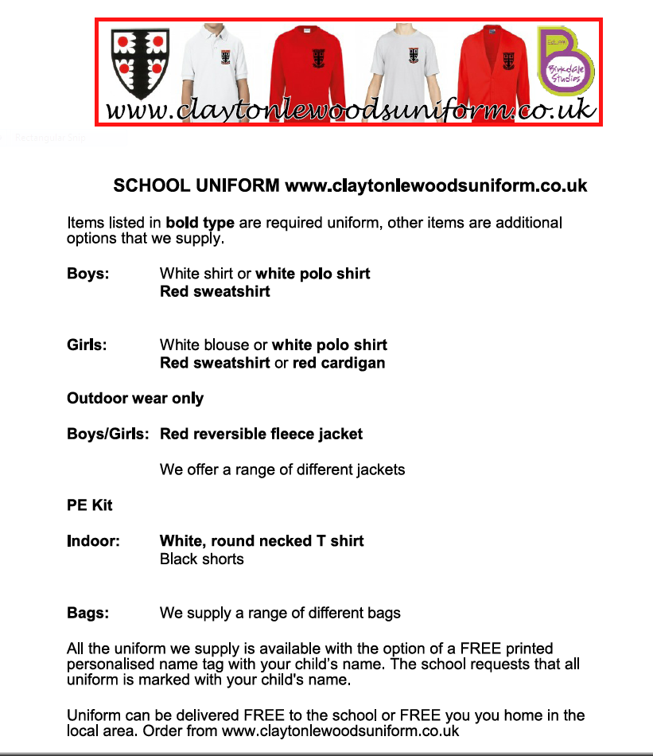

Monkhouse Schoolwear
Uniform store in Preston, England

Located in: Fishergate Shopping Centre

Address: Fishergate Shopping Centre, 49 Fishergate, Preston PR1 8HJ

Hours:
Closed ⋅ Opens 10AM Sat
Phone: 01772 259586

CARE CLUB
NEW TELEPHONE NUMBER 07517818499 PLEASE USE TO CANCEL OR BOOK SESSIONS

HOMEWORK

RECEPTION - Homework packs and reading books.

YEAR 1 – Learn a poem for the Off by Heart Poetry Competition.

YEAR 2 – Learn Off by Heart Poetry.

YEAR 3 – Maths CGP page 11, 12 and 13.

YEAR 4 – Home reading and learn a poem for the Off by Heart Poetry Competition.

YEAR 5 – Research your delegated country for our persuasive leaflets in English. Weekly spellings, reading and times tables practice.

YEAR 6 – Researching a significant person to write about in a biography in English. CGP Grammar book pages 4-7 inclusive and CGP spellings pages 4-6 inclusive.

Dates for your Diary
Dates may be subject to change
Monday 3.30pm - 4.30pm | Netball Yr 1 & 2
Tuesday 3.30PM to | After school Football  Yrs 2,3,4,5,6
Wednesday  8am to 8.45am | Archery Yr 1 & 2
Wednesday  3.30pm – 4.30pm | Handball Yr 1 & 2
Thursday  3.30pm - 4.30pm | Dodgeball Yrs 3,4,5,6
Wednesday  3.30pm – 4.30pm | After school Football  Yrs 3,4,5,6
Friday  8am – 8.45am | Tri-Golf Yrs 1 & 2
Friday  3.30pm – 4.30pm | Tag Rugby Yrs 3,4,5,6
Friday 3.30pm to 4.30pm | Absolute Futball doing Multi Sports
School closes for  Half Term | 3.30pm 19th October
School reopens | 29th October
30TH OCTOBER 2018 | RETURN PHOTOGRAPH ORDERS BY TODAY
Friday 9th November | Fireworks at school
Tuesday 13th November | School Open Day 9am to 3pm. Tours at 10am & 11am also 1pm and 2pm.
Saturday 17th November | PTFA Nearly New Sale in the School Hall, 11am to 2pm. £10 for a table. Please contact PTFA claytonlewoodsschoolptfa@gmail.com

Reminder
Please remember if your child is absent please ring the absence number and leave a voicemail. Please also ring school if your Child will be in late, this way we can plan lunch numbers.
01772 335 030 –
Option 1 to report an absent child

FREE SCHOOL MEALS

If you think you may be entitled to Free School Meals, please contact the school office for a form to complete or go on to Lancashire County Council’s website
www.lancashire.gov.uk/children-education-families/schools/free-school-meals/
Where there is a form online to complete. Even if your child wants to bring a packed lunch to school and doesn’t want a hot dinner, claiming for Free School Meals brings money into school and so helps the school.

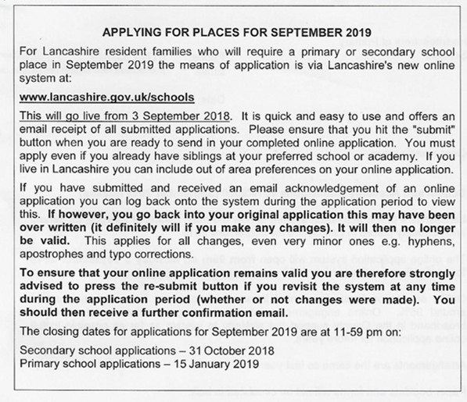
PARENT PAY

IF NOT DONE SO ALREADY CAN PARENTS ACTIVATE THEIR
PARENT PAY ACCOUNT.

A LETTER WITH A USERNAME AND PASSWORD WENT HOME WITH CHILDREN.
AS OF TODAY 15th OCTOBER, ONLY 70% OF PARENTS HAVE ACTIVATED THEIR ACCOUNT.
55 FAMILIES NEED TO ACTIVATE THEIR ACCOUNT.

IF YOU REQUIRE YOUR USERNAME AND PASSWORD CONTACT THE OFFICE.

AT THE MOMENT PARENT PAY IS ONLY FOR CARE CLUB HOWEVER SCHOOL STILL NEEDS YOU TO ACTIVATE YOUR ACCOUNT EVEN IF YOUR CHILD
DOES NOT USE CARE CLUB AS IT WILL BE ROLLED OUT FOR TRIPS AND DINNER MONEY
IN THE NEAR FUTURE.
PAYMENT IS BY CASH OR CHEQUE MADE PAYBLE TO: ‘FRIENDS CLAYTON LE WOODS CE PRIMARY SCHOO
Attendance & Punctuality In School

Some interesting facts:

- Missing just 10 minutes of school a day is the same as missing two weeks over the school year.
- 90% attendance is equivalent to missing 100 hour long lessons.
- If you take your child on a 2 week holiday in term time, attendance for the year immediately drops to 95%.
- 90% attendance means ½ a days absence each week; 4 weeks over the year & half a years absence over 5 years!!!!!
- 90% attendance is equivalent to a full month off school in a year.
Did you know?
- Around 85 million days are lost to absence each year.
- A 2 week holiday in school time means your child has approximately 50 hours of missed work to catch up on!!!

Just some interesting facts regarding punctuality and attendance. Although we aim for 100% attendance, each year we set a target for attendance and this is used to compare us to other schools nationally.

Clayton-le-Woods attendance for the last school year was 96.54%, Spring term it was 96.33% and the last half term was 96.25%. Our target this year for attendance is 97.5%.

School starts at 8.50am and ends at 3.30pm.

Head Lice - Check for Head Lice

Don’t forget to check for head lice. Below are some NHS ideas for keeping the little beasties in check.

How to get rid of head lice
There is no need to keep your child off school if they have head lice.
USE LOTION or SPRAY TO TREAT HEAD LICE.
You can use medicated lotion and sprays that kill head lice in all types of hair. You can buy these from pharmacies & supermarkets.
Head lice should die within a day. Lotions and sprays come with a comb to remove dead lice and eggs. The comb can then be used at a later date to comb through the hair at bath time.
Some treatments need to be repeated after a week to kill any newly hatched lice. Check the pack to see if they are OK for you or your child and how to use them.

If lotions or sprays don’t work, speak to your pharmacist about other treatments.

There is nothing you can do to prevent head lice. You can reduce the risk of lice spreading by avoiding head to head contact & k0eeping long hair tied back.
Ask if your pharmacy is involved with the Minor Ailments Scheme, as detailed below.

Pharmacy First, Minor Ailments Scheme (Chorley & South Ribble and Greater Preston CCG Areas)
This service encourages patients to self-refer to their local community pharmacy. The community pharmacy will treat minor ailments and supply medicines according to the Greater Preston CCG minor ailments local formulary. Medicines will be supplied free for patient exempt from prescriptions charges.
The Minor Ailment Scheme provides patients living in the South Ribble area with advice and access to medicines through community pharmacies where appropriate, supporting integration and self-care. The pharmacist or suitably trained member of pharmacy staff should carry out a professional consultation with reference to the minor ailment scheme formulary. This will involve:
- a patient assessment;
- provision of advice;
- completion of minor ailments online consultation form in accordance with the CCG’s protocols; and
- supply of medicine(s) from the agreed formulary where appropriate.

Cheques payable to school should be as follows:
- for lunches to: ‘LCC Schools Income Account’
- Cheques for Care Club to: ‘Clayton-le-Woods CEP Child Care Club”.
- Cheques for trips to: ‘Clayton-le-Woods CE Primary School’
- Cheques for PTFA to ‘Friends Clayton le Woods CE School’
- Parent Pay is now an option to pay for Care Club. Registration is need before
payment can be made, call in the office to receive your username and password.
Parking
- Please do not park on the pavement outside the Pre-school classroom. This is very dangerous for our children.
• Take care when driving through the car park as there are children around.
• DO NOT park either on the yellow zig-zags or across the road from the zig zags during the busy drop-off and pick-up times.

Jewellery No jewellery apart from watches are allowed to be worn.
Prices
Book Bag £4.75
PE bag £3.50
School Meal £2.20 PLEASE DO NOT ALLOW CHILDREN TO WALK ON THE LOW WALL
Care club £3.50 PER HOUR THAT RUNS ALONG THE FOOTPATH, AS THIS MAY CAUSE DAMAGE TO
THE WALL OR INJURY.

.INFANTS

Infants require tights, socks and spare clothing for when children have accidents. If any clothing has been sent home previously please send them back into school.

GUITAR LESSONS

There will be a beginner’s guitar group starting in September on Wednesday afternoons at 12.30pm - 1.00 pm. The lessons will be provided by Carmel Galea who teaches at many local Primary and High schools.

email :carmel@cmg-guitars.co.uk

Attendance & Punctuality in School

Some interesting facts:
- Missing just 10 minutes of school a day is the same as missing two weeks over the school year.
- 90% attendance is equivalent to missing 100 hour long lessons.
- If you take your child on a 2 week holiday in term time, attendance for the year immediately drop to 95%.
- 90% attendance means ½ a days absence each week; 4 weeks over the year & half a years absence over 5 years!!!!!
- 90% attendance is equivalent to a full month off school in a year.
Did you know?
- Around 85 million days are lost to absence each year.
- A 2 week holiday in school time means your child has approximately 50 hours o missed work to catch up on!!!

Just some interesting facts regarding punctuality and attendance. Although we aim for 100% attendance, each year we set a target for attendance and this is used to compare us to other schools nationally.

Clayton-le-Woods attendance for the last school year was 96.54% and last term it was 96.33%. Our target this year for attendance is 97.5%.

School starts at 8.50am and ends at 3.30pm.

100 CLUB WINNERS FOR JULY
1ST PRIZE Mrs Fahy
2ND PRIZE Mr L Wright
3RD PRIZE Mrs C Stansfield

100 CLUB WINNERS FOR AUGUST
1ST PRIZE Mrs M Papworth
2nd PRIZE Mrs H Dixon
3RD PRIZE Mrs H Stansfield

CARE CLUB – BREAKFAST & AFTER SCHOOL
Please note Breakfast Club is held in the Junior School Building
Care Club is available for all children within the school, and is open from 7.50am until 8.50am and after school from 3.30pm-5.30pm.
Please ring 07517818499 or email school if you need to cancel a Care Club booking especially if cancelling a morning booking on the day.
Please pre-book your child for the following month on a paper booking form available from Care Club or the school office. Payment straight away would be appreciated. Places are limited due to numbers increasing so please send in your form as soon as possible.
If you need to cancel please let us know in advance or you will be charged for your child’s unused place.
Offering a range of fun sports and activities, alongside friendly
competition, we offer a fantastic opportunity to keep your children active throughout the holidays.
Call our reception team on 01772 315907, or pop down to the centre to book your child’s place
*Please ensure your child brings a packed lunch and a refillable water bottle.
Offering a range of fun sports and activities, alongside friendly
competition, we offer a fantastic opportunity to keep your children active throughout the holidays.
Call our reception team on 01772 315907, or pop down to the centre to book your child’s place
*Please ensure your child brings a packed lunch and a refillable water bottle.
Phone:
07779 691192

School Gardening Club

Mr Howard, Mrs Seers & Mr Molloy are starting a Gardening Club and would like parents to send in any tools, pots or gardening related items to help the children get started.
If parents have any pairs of gloves they don’t use for gardening, the Gardening Club will be able to make use of them.
Progress reports will follow.
Week 1
We had our first meeting on Friday 14th September. The children worked very hard clearing weeds and stones from the border that runs alongside the path near the infant building.
The club have a request to parents, if anyone is able to send in spring flowering bulbs & pots of herbs, we intend to plant them along the border to brighten the path up in Spring, If anyone has any Strawberry runners we would like to plant the tyres up with them in the garden area. Also if anyone has any gardening gloves or tools they wish to donate, they will be greatly received.
Week 2 Rained off.
Week 3 The children were busy again this week. They planted up Lavender, Chives and Parsley, which were kindly donated by a parent. The children also helped Mr Howard lay a weed membrane and cover it with stones to stop weeds coming up near the infant building. Some children also helped Mr Molloy clear weeds from the tyres so they are ready for planting strawberries.
School still need gardening gloves and hand tools so that all the children who have volunteered have each got gloves and a hand tool.
Week 4
The children only had 10 minutes of gardening and they were then rained off.
Week 5
Too wet and windy
Payments into school
Can cash or cheques be sent into school in an envelope marked with the child’s name, class and what the money is for. This will make sure the money does not go astray and will make it easier in the office to allocate it.
PARENT PAY UPDATE
Parents should have received a letter with their Parent Pay activation code for using Parent Pay to pay for Care Club. Please activate as soon as possible even if not using Care Club as we will be using Parent Pay in the future to pay for dinner money and trips.

 |  | List of Activities This Term
Wednesday, October 17th |  | Re-start a heart day
Wednesday, October 17th | Parents Evening | Letters have been sent out, please return as soon as possible
Thursday, October 18th | Parents Evening | Letters have been sent out, please return as soon as possible
Friday, October 19th | Non-uniform day | Can we please have donations of bottles or raffle prizes for Bonfire PTFA Event on 9th November.  School closes for half term.
Friday, October 19th | Enrichment morning
Friday, October 19th | Poetry Competition finals | School hall in the afternoon
Monday, October 29th | School re-opens | Reception classroom is being refurbished during the half term holiday.
Tuesday October 30th | Photograph orders | Please return photograph orders by today
Week beg November 5th | Y6 Bikeability
Week beg November 5th | Theme week | Children will be learning about World War 1. At 2pm on Monday, November 9th our two Year 6 Pupil Parliament delegates will meet at Whittle Cenotaph along with representatives from other local schoolsfor a short service of remembrance.
Friday, November 9th. | PTFA Bonfire Event | Gates open 6pm
Tuesday, November 13th | OPEN DAY | School open to prospective parents for children starting school September 2019. Tour with Head Teacher at 10am, 11am, 1pm and 2pm
Friday, November 16th | CHILDREN IN NEED | Children come to school in non- uniform including something spotty. Donation of £1 for Children in Need
Tuesday, November 27th | Rotary Shoebox Appeal
Friday, November 30th | ChristmasTree decorations | Please can tree decorations be brought into school by today so that we can decorate the Christmas Tree.
Friday, November 30th | Non uniform day | Can we please ask for donations of bottles for the tombola for the Christmas Fair.
Friday, December 7th | Christmas clothes day  Voluntary £1 donation for Christmas Jumper Appeal. | As we are at the pantomime on 14/12, which is Christmas Jumper Day, the children can come to school in non-uniform on Friday December 8th with a Christmas theme. This does not need to be a Christmas jumper.
Friday, December 7th | PTFA Christmas Fair | Fair starts at 3.45pm. Children will go out of school as normal and return to the fair with parents/carers. If your child is in Care Club please let Mrs Bolton know if you are collecting them to go to the fair, would like someone from Care Club to take them to the fair or want them to stay in Care Club. Care Club will be in Y3 with access by the Y3/6 door
TBA | Carol singing at Asda | Y5/6 pupils will be joining pupils from other local schools at Asda Clayton Green at 10am until 11am. (Miss Carr and Mrs Pennington.)
Tuesday, December 11th | Dress rehearsals | Preschool and reception 10.30am. Year 1 and 2 2pm. Please ask class teacher if you wish to attend.
Wednesday, December 12th | Pre-school and reception class Nativity | Performances in the school hall at 2pm and 6pm. For the evening performance please bring the children back to school by 5.40pm in their costumes. The performances will be videoed if all parents agree. These will be on sale after the event. There is no entrance charge. Refreshments will be available to buy. For fire regulations seating is limited therefore entrance is by ticket only. These will be available from December 4th,
Thursday, December 13th | Year 1 and Year 2 Nativity | Performances in the school hall at 2pm and 6pm. For the evening performance please bring the children back to school by 5.40pm in their costumes. The performances will be videoed if all parents agree. These will be on sale after the event. There is no entrance charge. Refreshments will be available to buy. For fire regulations seating is limited therefore entrance is by ticket only. These will be available from December 4th,
Friday, December 14th | Reading morning | Coffee and tea available from 8.40am in school hall.
Friday, December 14th | Pantomime | The children should wear school uniform. They will have lunch before leaving and we will take a snack and drink with us. We should be back at school at about 4pm. A message will be sent out by the office when we have an ETA. If you would like to volunteer to help please let school know.
Monday, December 17th | Year 3 and 4 Christmas parties. | Children from Y3/4 can wear their own clothes all day. Teachers will send out a letter regarding party food,
Tuesday, December 18th | Year 5 and 6 Christmas parties. | Children from Y5/6 can wear their own clothes all day. Teachers will send out a letter regarding party food,
TBC | Choir | Carol singing art Willow Bank Care Home 4pm (Mrs Howlett and Miss Carr)
Wednesday, December 19th | Infant Christmas parties. | Children from Preschool, YR, Y1 and Y2 can wear their own clothes all day.  Teachers will send out a letter regarding party food,
Thursday, December 20th | Christmas lunch | Please send form and money to school office.
Thursday, December 20th | Candlelight Service | 6pm at St John’s Church Whittle. All children take part in the Service which lasts about an hour. Parents and families are welcome.
Friday, December 21st | School closes | 2pm. No Care Club. Enrichment morning. Children will choose from a range of activities. No toys please.

Life in ‘Likes’
Social media use among 8-12 year olds:

Executive Summary
Most social media platforms have a minimum age limit of 13, but research shows a growing number of children aged under 13 are using social media, with 3 in 4 children aged 10-12 having their own accounts.
While much is known about how teenagers use social media, this research provides the missing piece to the story, exploring the social media lives of children before they reach the teenage years. In October and November 2017, we conducted 8 focus groups with 32 children aged 8-12 to understand the impact of social media on the wellbeing of this age group. The findings of this research are summarised below.

How I use social media

My social media:
Across all ages, the most popular social media were Snapchat, Instagram, Musical.ly and WhatsApp. Younger children had less routine around when they accessed social media, while older children started to get into the habit of using all their social media apps multiple times a day, and for some, it had come to dominate their day.

Social media makes me feel happy
Children knew how to cheer themselves up or calm themselves down using social media, from getting funny Snapchats from a friend to watching slime videos on Instagram. It allowed children to be creative and play games, two things that appealed to children from a very young age.

How I stay safe online:
Parents and schools had successfully ingrained messages in children about online safety from known risks such as predators and strangers. Yet children were less aware of how to protect themselves from other online situations that could affect their mood and emotions.

My friends and family

‘Following’ my family:
Younger children were particularly influenced by their family’s views and usage of social media, and parents may be unaware of how their use of social media affects their child.

Going on my mum’s phone
Parents sometimes gave children contradictory safety messages when they let children use their social media accounts, and unknowingly exposed them to unsuitable content.

Sharenting
Many children felt uncomfortable and bothered by their parents posting pictures of them on social media, yet felt they could do little to stop it.

My sister showed me Snapstreaks
Children learned how to do new things on social media from their older siblings, but were also put off by things that their siblings had experienced. In some cases, children worried about their siblings’ behaviour online, such as excessive use and ignoring safety messages.

My online friends:
Social media was important for maintaining relationships, but this got trickier to manage at secondary school, where friendships could break down online.

Keeping in touch
Children used social media as a tool to maintain friendships, and they recognised the value of face-to- face interactions for more serious conversations, like discussing worries and resolving arguments.

Falling out online
Younger children were more likely to see mean comments from strangers on apps like Roblox, whereas older children, who were communicating with a greater number of people on group chats, faced issues and confusion around the blurring of ‘jokes’ that were posted publicly.

I need to reply now
Maintaining online friendships could be stressful for some and a source of distraction from other offline activities.

Growing up on social media

Who should I be?
Children are conscious of keeping up appearances on social media, particularly when they start secondary school, and identity and seeking peer approval become more important.

Do I look okay?
Despite talking about the importance of ‘staying true to yourself’ and being authentic on social media, girls were worried about looking ‘pretty’ and boys were more concerned with looking ‘cool’ and having the right clothing.

Can we all look like celebrities?
When children started to follow celebrities and people outside their close family and friends, many became aware of how they looked compared to other people on social media, and felt that comparisons were unattainable.

Will my picture get any likes?
Children felt good when they got ‘likes’ and ‘comments’ from friends, and some Year 7 children were starting to become dependent on them, using techniques to guarantee they would get a high number of ‘likes’.

Is this shareable?
Children started to see offline activities through a ‘shareable lens’ based on what would look the best on social media.

The world and my future:
Social media could inspire children and help them learn about new things.

I want to be a YouTuber when I am older
Some children developed new aspirations about what they wanted their future to be like and copied things they saw on social media.

Learning about the world
Some children actively gathered information on social media platforms like YouTube and Instagram, and were exposed to ‘news’ via celebrities and ‘explore/discover’ pages.

